CRITERIA VII – INSTITUTIONAL VALUES AND BEST PRACTICES
Best Practices - II

Title of the practice: SRI - Social Responsibility of Institute
Programme Report
On 11th February, 2020, NSS department of the College undertook an activity to promote social responsibility of the Institute. The objectives behind the activity was to serve the society with the available resources. Another objective was to serve the needy people and to conduct this drive in an effective way. Rehabilitation of child beggars was also taken into consideration while conducting this drive. NSS department of the College had been working in this field for a very long time. The students conducted many awareness programmes in the villages adjoining to Gondia city.
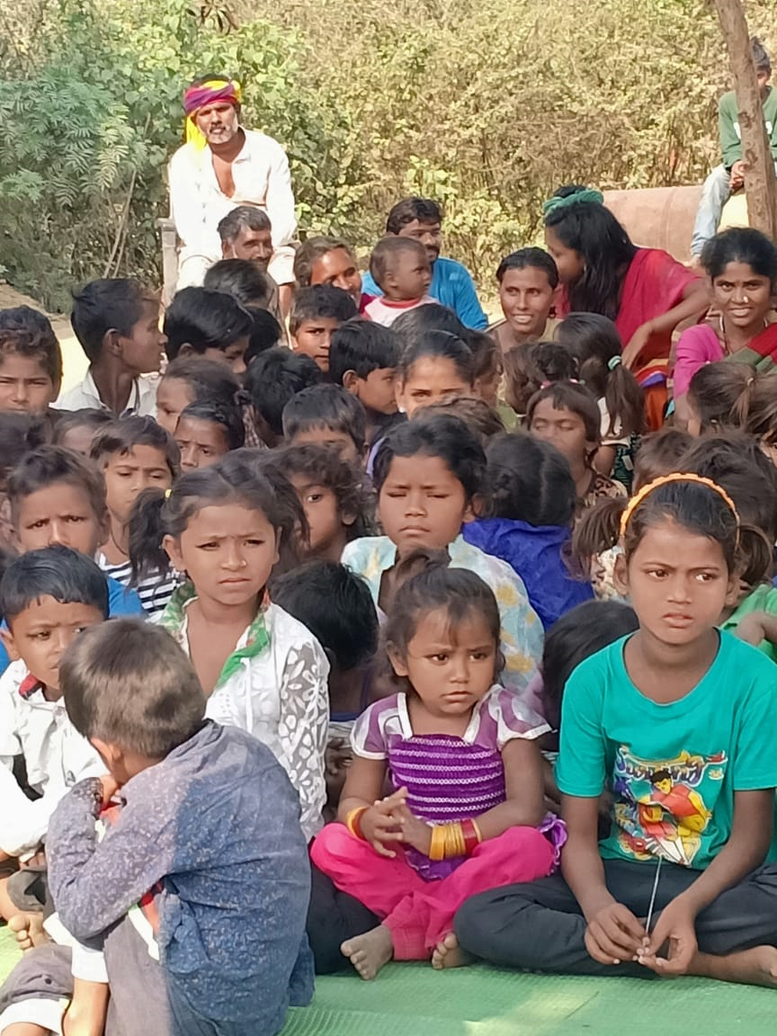

Serving the people was the fundamental purpose behind this best practice. Gondia city is surrounded by many villages and hamlets. Many people living around the city were found to be economically needy. With the idea of serving them, clothes and various items were distributed to Nomadic Tribe people. Distributed of clothes and necessary goods were provided by the institute. These goods were collected from various sources who voluntarily contributed to this practice. This practice includes – Providing financial help, clothes and necessary items, helping in their temporary settlement and rehabilitation of child beggars.
The activities under this practice received huge response from the faculties and students. Every one contributed according to their capacity for the clothes and other items. After collection, these items were distributed in a particular area. The evidence of the success of this practice can be marked and seen through photographs.
