CRITERIA VII – INSTITUTIONAL VALUES AND BEST PRACTICES
Institutional Distinctiveness
Report
N.M.D. College Gondia is the pioneering college of Gondia Education Society committed to cater the needs of the rural and backward students of the district.
Agro Exhibition is one of the distinctive features of the College. Since an educational institution is responsible for contributing in national development, the College organizes this exhibition to provide a platform to local farmers to show their skills and products. The exhibition is organized to make the people aware about the distinctiveness of their locality as far as the agricultural achievements are concerned and to honour the local farmers for their the organic crops and innovative agri products..
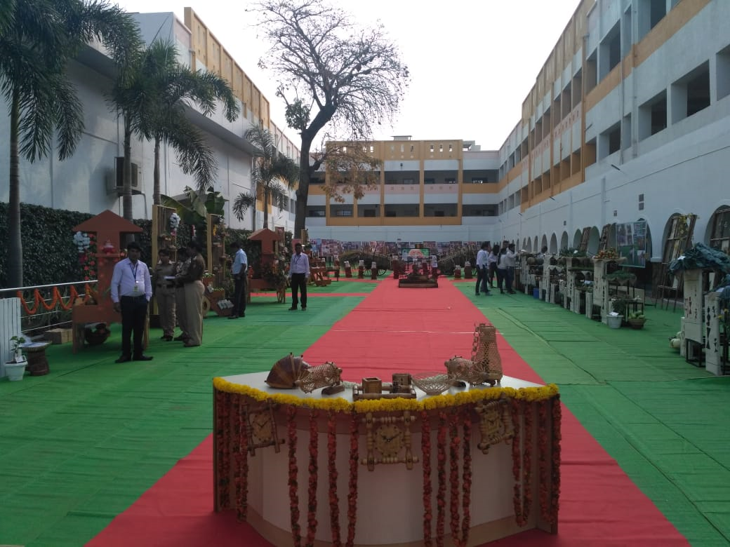
It is one of the activities which bring laurels to the college and gives distinctiveness to it. Every year on 9th February, this exhibition is organised as a tribute to Late Shri Manoharbhai Patel. On his birth anniversary, to honour the local farmers and to highlight their contribution, this exhibition is organised.

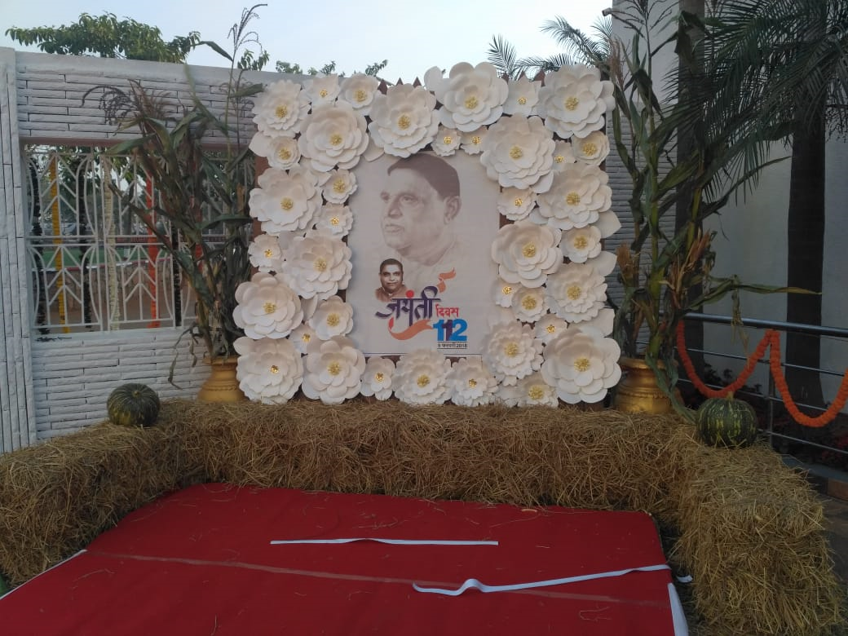

The exhibition is also opened for the general public as well. People from the Gondia district come to see the beauty and innovativeness of this exhibition. Many organic products along with the handmade things are displayed in the College premises. The efforts are jointly taken by the Faculty team and student team who work day and night to ensure the success of this exhibition. Students are encouraged to take up responsibilities for conducting various activities and programmes for their overall development.

