CRITERIA VII – INSTITUTIONAL VALUES AND BEST PRACTICES
Best Practices - I

Title of the practice: Development of Entrepreneurial Skills
Programme Report
On 14th and 15th January, 2019, the students of Department of Business Administration, N.M.D. College Gondia organised a programme to develop their Entrepreneurial Skills under the leadership and guidance of Dr. Girish Kudle. The objective behind undertaking the activity was to develop business and entrepreneurial skills in the students, creating understanding of an enterprise and enlightening the students about the practical world and the concept of limited resources. The main aim was to create a scenario of the 21st century and the need of developing skills to survive in this highly competitive world.

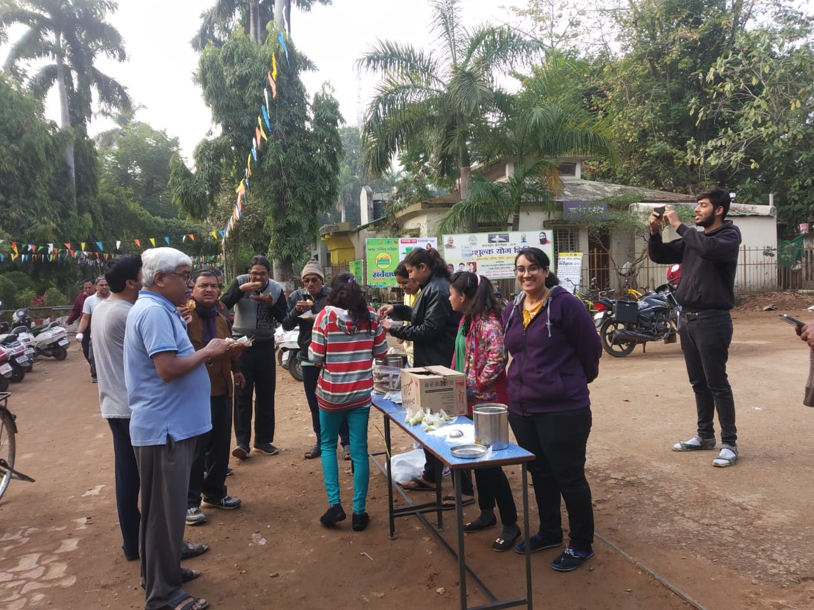

The context of the activity lies in the reality of the practical world. To develop the entrepreneurial skills in the students, they are given a capital of Rs. 100/- with a task to maximize this capital through various business activities. Each team uses its Rs. 100/- corpus fund for various small businesses to maximize the capital. For this activity, the students are divided into three teams and the best earning team is awarded a prize. The evaluation of the team is on the basis of the idea of business, execution of business area served and profit earned.
There was a huge response from students from MBA department. To implement their business ideas the students worked day and night. They processed various ideas and implemented them on college premises. They sold Tea, Coffee, Homemade cookies, snacks and various items to spread the message that no business is small. What you need is just an idea and execution.
